What are the current costs associated with the maintenance and operation of critical infrastructure on Saibai Island?

Design Area and Project Opportunity: 6.2: ICT - Remote monitoring and diagnostics

Student Name: Alexander

Student ID: 25434491

Tutorial Number and Zone: Tutorial 2, Blue Zone

Project opportunity brief
Often, engineering solutions installed in remote locations can be challenging to access regularly and promptly, particularly in the wet season. It is often expensive and time consuming for technicians to understand when preventative maintenance is required at one site and how this should be scheduled relative to other sites. In addition, a critical challenge for appropriate design is the sheer cost of mobilising technical expertise to site to resolve system breakdowns in a timely manner. In this design area, teams may work to develop an online/offline remote monitoring and diagnostics tool that can be used to simplify and/or
or improve the efficiency of operation and maintenance programs for infrastructure, such as
communication technologies, pumps, treatment plants, battery systems, lighting, and other
infrastructure.

Background
Saibai is a small island only 4 km south of Papua New Guinea in the Torres Strait, legally a territory of Queensland, Australia. Due to the low and flat geography of the island, the small community that lives there is disproportionally affected by climate change, especially due to the rise in sea levels causing regular tidal flooding (Torres Strait Island Regional Authority, 2021, p. 55; Torres Strait Island Regional Council, n.d.). The islanders themselves do not produce enough profit for the the island to be self-sustaining, and a common source of income on the island is the welfare program Centrelink (Dev. S., n.d.). This, combined with the fact that the island community is small and the damage caused by enviromental changes is disproportionally severe, means that the Torres Strait Island Regional Council is dependent on State and Federal Government funding, which it receives in the form of grants and subsidies (Torres Strait Island Regional Council, 2023).

Infrastructure of Saibai Island
Critical infrastructure is physical and information infrastructure that is critical to maintain social or economic wellbeing. A disruption to any type of critical infrastructure can have large impacts on the people that rely on it every day. The Security of Critical Infrastructure Act 2018 (Australia) (s 8D) defines critical infrastructure sectors as those that relate to water and sewage, communications, energy, health care, food, and transport, among others. The critical infrastructure of Saibai Island includes a health centre, sewer infrastructure, electricity infrastructure, waste facilities, and water supply infrastructure. Much of the critical infrastructer on Saibai Island is without redundancy, and all of the island’s critical infrastructure is in areas prone to storm tide floods, putting all critical infrastructure on Saibai Island at risk (Torrest Strait Island Regional Council, 2018). If any of these pieces of critical infrastructure were to be damaged during the common floods, it could cause significant harm to the community living on the island. Issues with sewage infrastructure could cause waste transport to back up and communications problems would disconnect the islanders from the internet and prevent external communication. Most of the island is powered by generators, and damage to the energy infrastructure could leave the entire island without electricity wich is used to boil water for safety, store food and more. Damage to the health infrastructure could prevent treatment of otherwise commonly treated diseases or even prevent treatment of much more dangerous diseases or injuries, requiring transportation to other islands. Many of these life-dependent pieces of infrastructure depend on each other, and the individual problems of infrastructure damage in one area can be exponentially exasperated by damage to infrastructures in other areas, such as damage to both water supply and energy infrastructure, potentially resulting in unsafe drinking water that cannot be sanitised by boiling. Due to the nature of the floods on Saibai Island, when one piece of infrastructure is damaged due to flooding, several other pieces of infrastructure will be too (CoastAdapt, 2017). This can cause humanitarian crises on the island until critical infrastructure can be repaired. The tendency for several pieces of infrastructure to be damaged in the same floods also the issue of which infrastructure should be prioritised for repair, which may introduce further costs.

Cost of infrastructure maintenance
The worsening effects of climate change in recent years, as well as global supply chain challenges and infrastructure reaching the end of its life-cycle, whether due to sustained damage or wear and tear, has caused the cost of maintenance, repairs, and replacement of infrastructure to explode, as evident by recent Torres Strait Island Regional Council Annual Reports (2021; 2022; 2023). The cost of repair and maintenance across the Torres Strait has increased from 2.5 million dollars in 2021, to 5.9 million dollars in 2023, a more than two-fold increase in the span of 2 years. In 2020, 960 thousand dollars went to Saibai alone, not factoring in engineering projects that spanned several islands, and this number is only growing in size much like the TSIRC maintenance budget (Torres Strait Island Regional Council, 2020).

As climate change worsens, the global temperatures continue to rise, the permafrost of the arctic and antarctic ice caps continue to melt, the sea levels continue to rise and the Torres Strait Islands continue experiencing worsening floods, storms and other environmental disasters, the cost associated with repairing and maintaining the infrastructure on Saibai Island will only grow unless drastic measures are taken to prevent these environmental issues from ravaging the islands in this area. Massive investment is required for preventative infrastructure such as seawalls to prevent annual flooding, whose cost may be too great in the eyes of those investing.

References
CoastAdapt. (2017). Adapting to sea-level rise in the Torres Strait.
https://coastadapt.com.au/sites/default/files/case_studies/CS011_Adaptation_in_the_Torres_Strait.pdf
Dev. S. (n.d.). Notes on an interview with Sai Rupa Dev.
Security of Critical Infrastructure Act 2018 (Australia).
Torres Strait Island Regional Council. (n.d.). Saibai. https://www.tsirc.qld.gov.au/communities/saibai. (Retrieved 2024, August 17)
Torres Strait Island Regional Council (2018). Saibai Island maps [Map]. https://ewb.app.box.com/s/htwdu5gwjdbsrw7oo9lnypdgwdk2u9b7
Torres Strait Island Regional Council. (2020). Statement of Financial Position.
https://www.tsirc.qld.gov.au/sites/default/files/2019-2020%20Original%20Budget%20-%20Website.pdf
Torres Strait Regional Authority. (2021). Torres Strait 2021 State of Environment Report Card. https://ewb.app.box.com/s/y0w4m9hwyidzx452rehnsij3k9acs9wo.
Torres Strait Island Regional Council. (2021). TSIRC Annual Report 2020-2021. http://www.tsirc.qld.gov.au/files/annual-report-2020-2021
Torres Strait Island Regional Council. (2022). TSIRC Annual Report 2021-2022. https://www.tsirc.qld.gov.au/files/annual-report-2021-2022-spread-digitalpdf
Torres Strait Island Regional Council. (2023). TSIRC Annual Report 2022-2023. https://ewb.app.box.com/s/hwfeyi6uotladql4e33za3kmsfswrz00

Appendix 1: Sources
CoastAdapt. (2017). Adapting to sea-level rise in the Torres Strait.
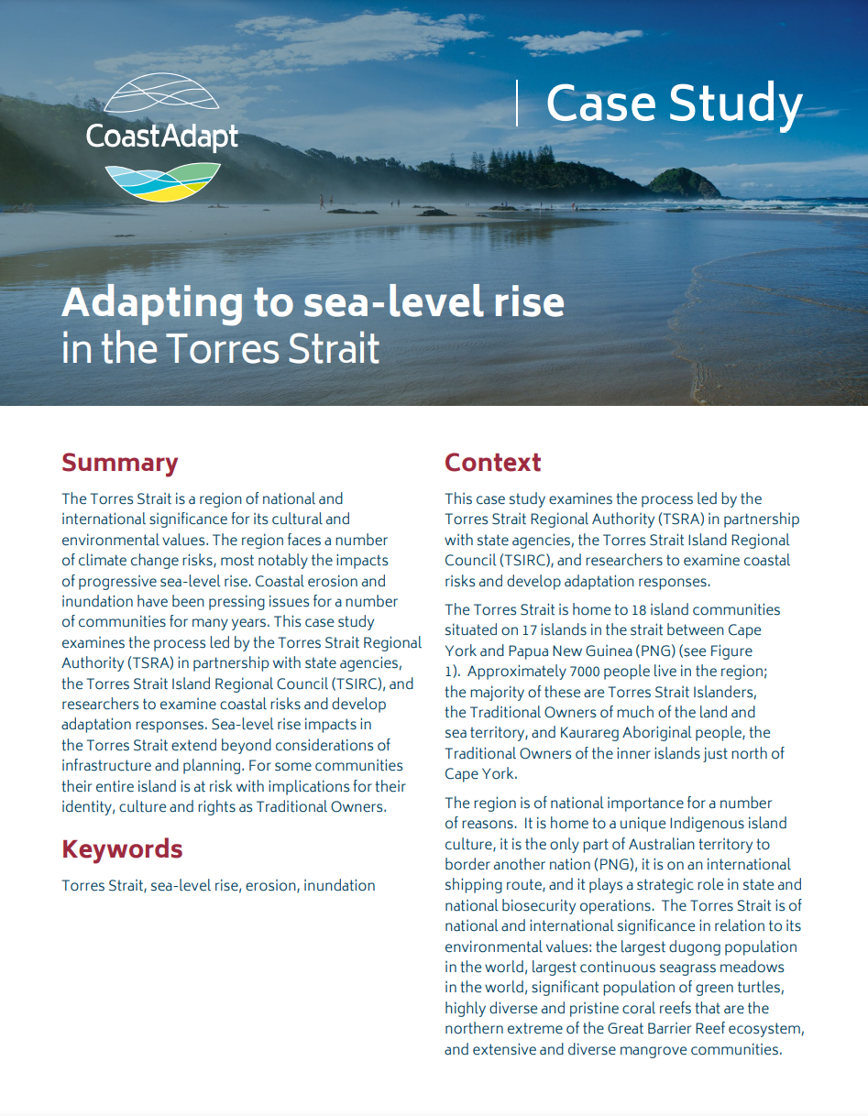

Dev. S. (n.d.). Notes on an interview with Sai Rupa Dev.
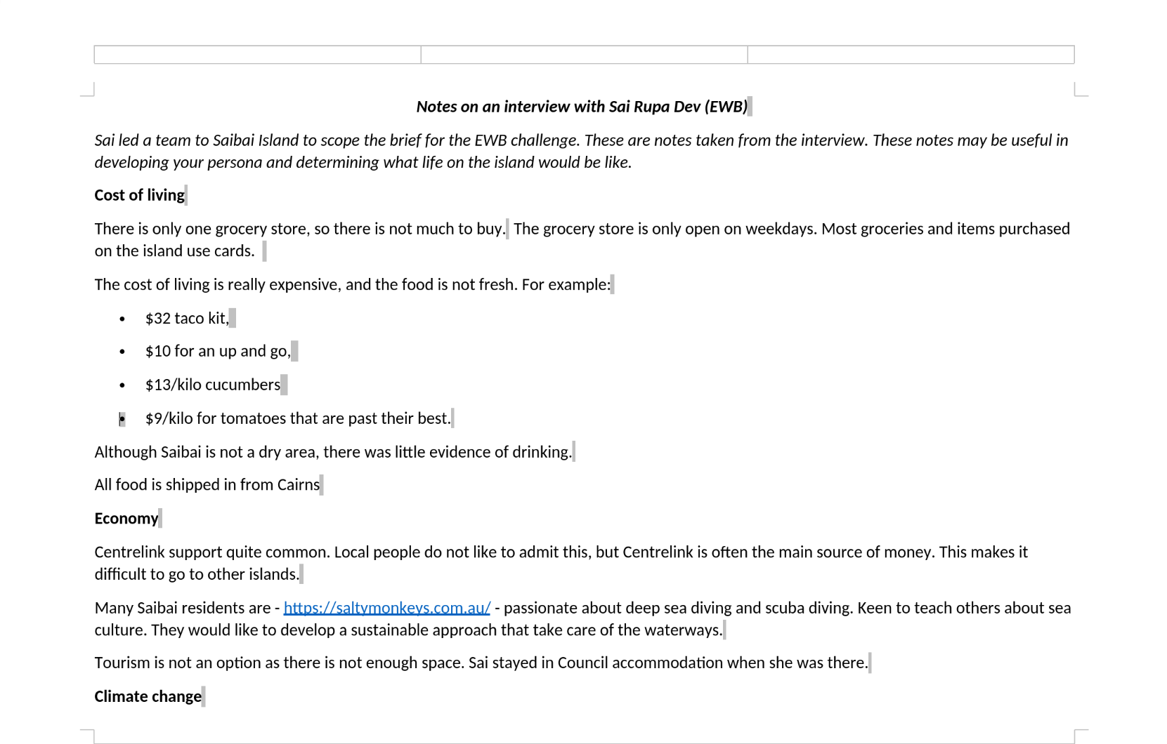

Security of Critical Infrastructure Act 2018 (Australia).
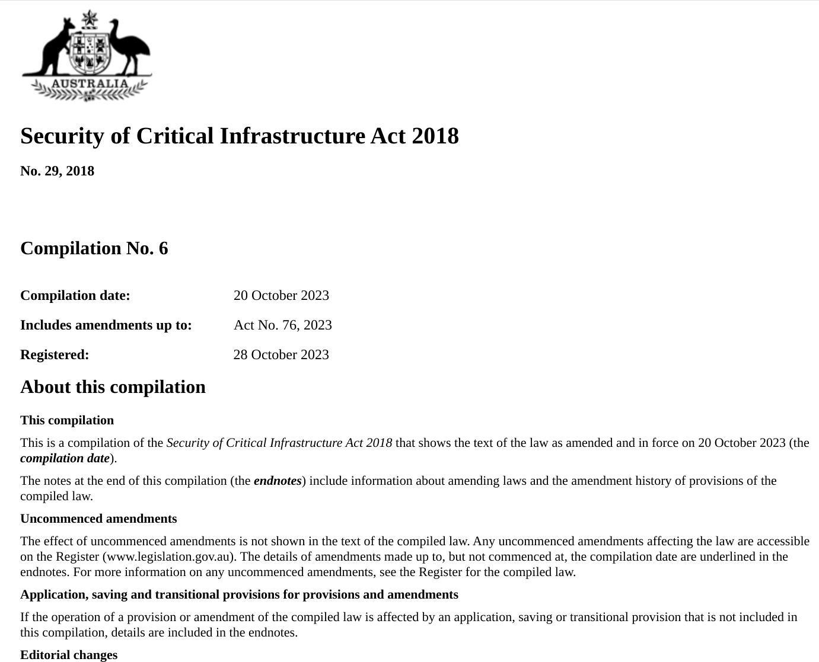

Torres Strait Island Regional Council. (n.d.). Saibai.


Torres Strait Island Regional Council (2018). Saibai Island maps.
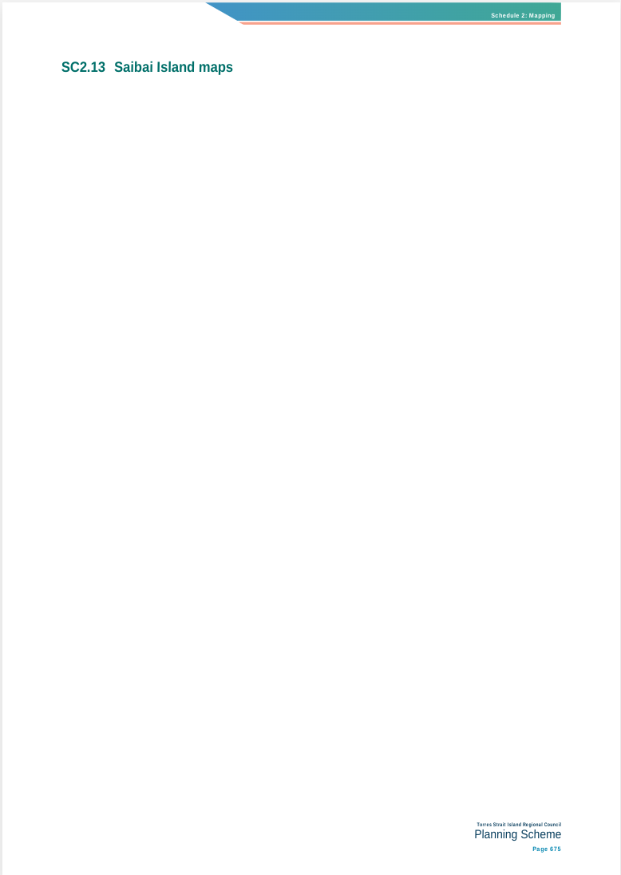

Torres Strait Island Regional Council. (2020). Statement of Financial Position.
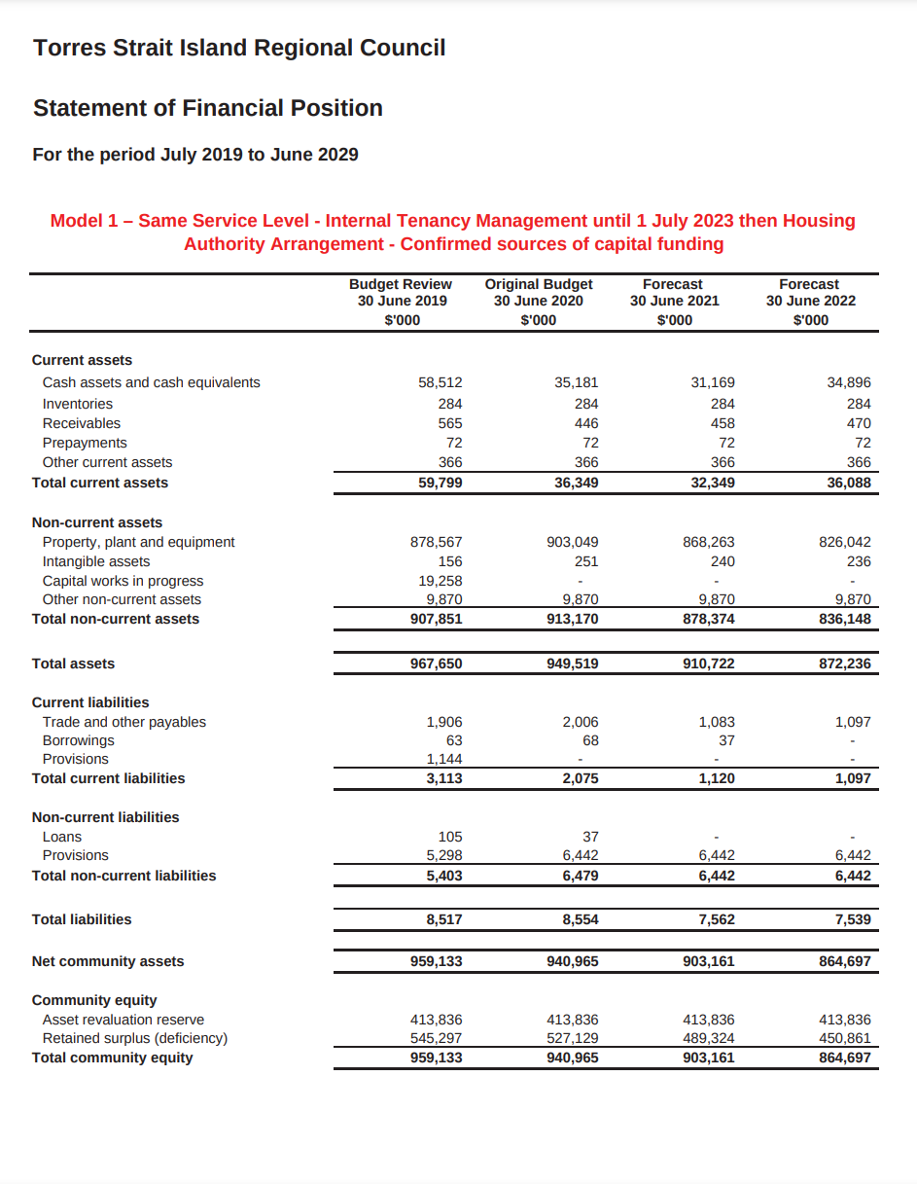

Torres Strait Regional Authority. (2021). Torres Strait 2021 State of Environment Report Card.
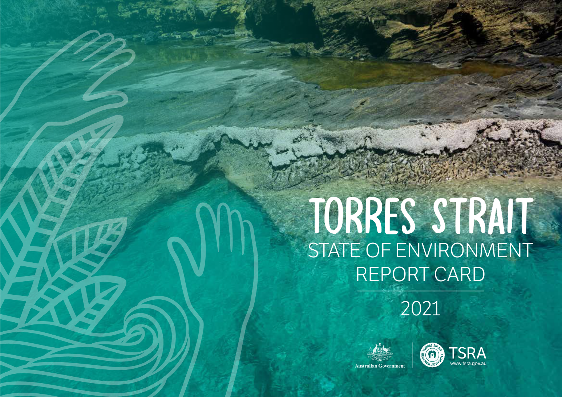

Torres Strait Island Regional Council. (2021). TSIRC Annual Report 2020-2021.
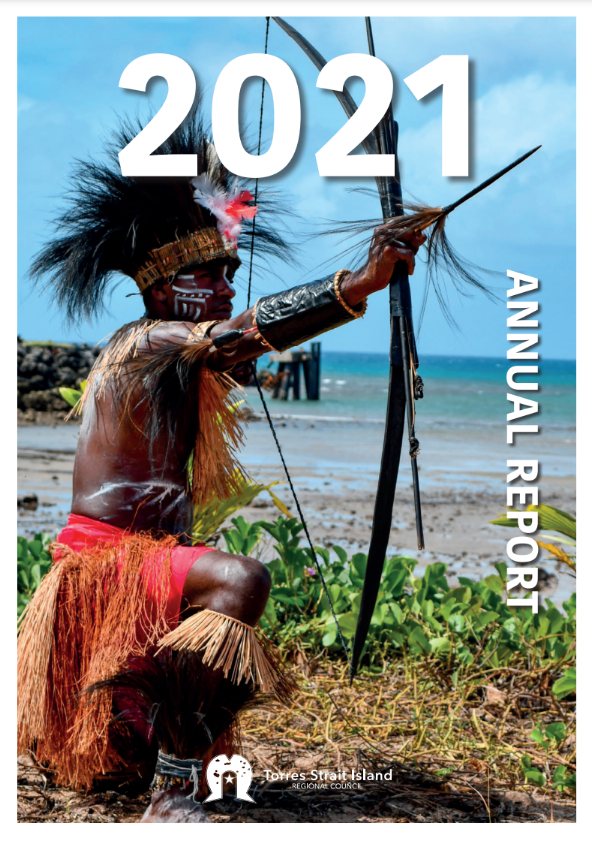

Torres Strait Island Regional Council. (2022). TSIRC Annual Report 2021-2022.


Torres Strait Island Regional Council. (2023). TSIRC Annual Report 2022-2023.


